Name: V.Siri Chandana
Roll No:2520030609
Section:2
Subject:OS
Programs:
3.

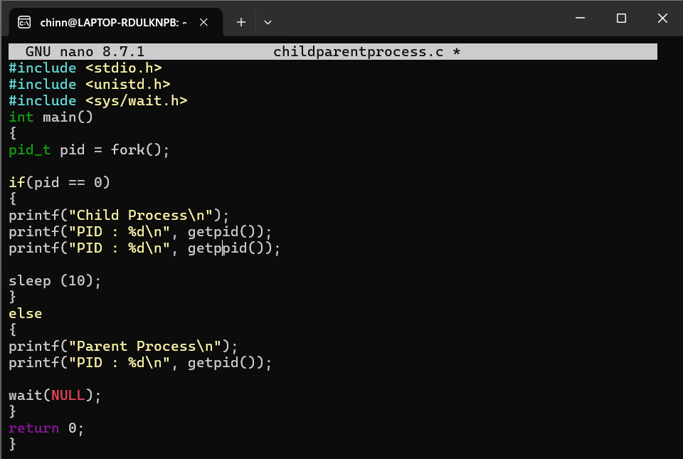

Output:

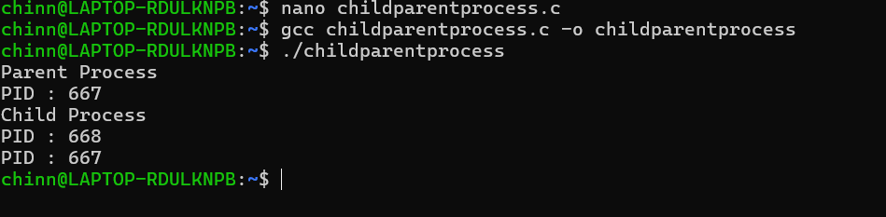

4.

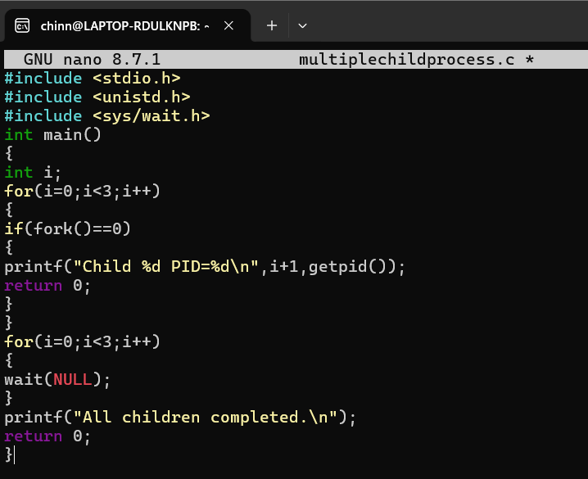

Output:

